Nama : Lilis Sonia

NIM :18090051

Kelas : 5D

**PRAKTIKUM 5**

1. Source Code

Autoload.php => application / config.php

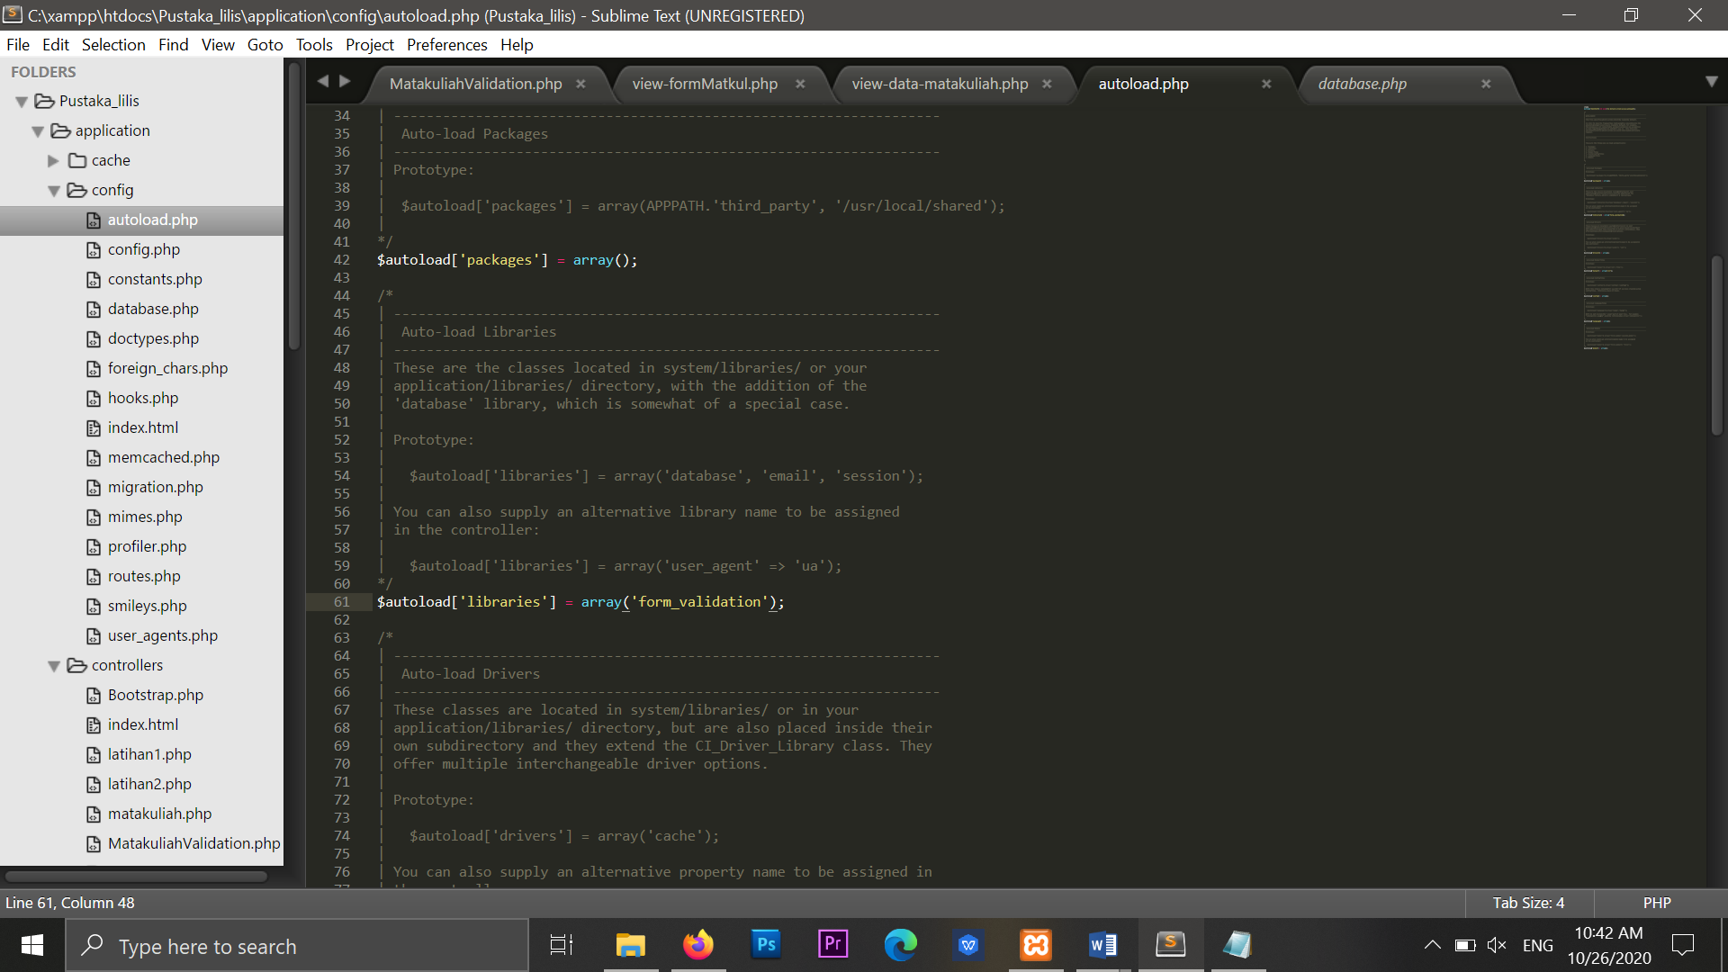

MatakuliahValidation.php => application/controller/MatakuliahValidation

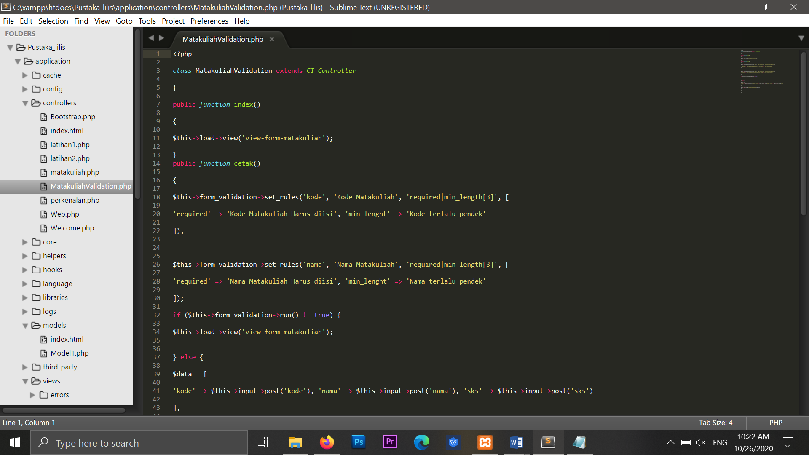

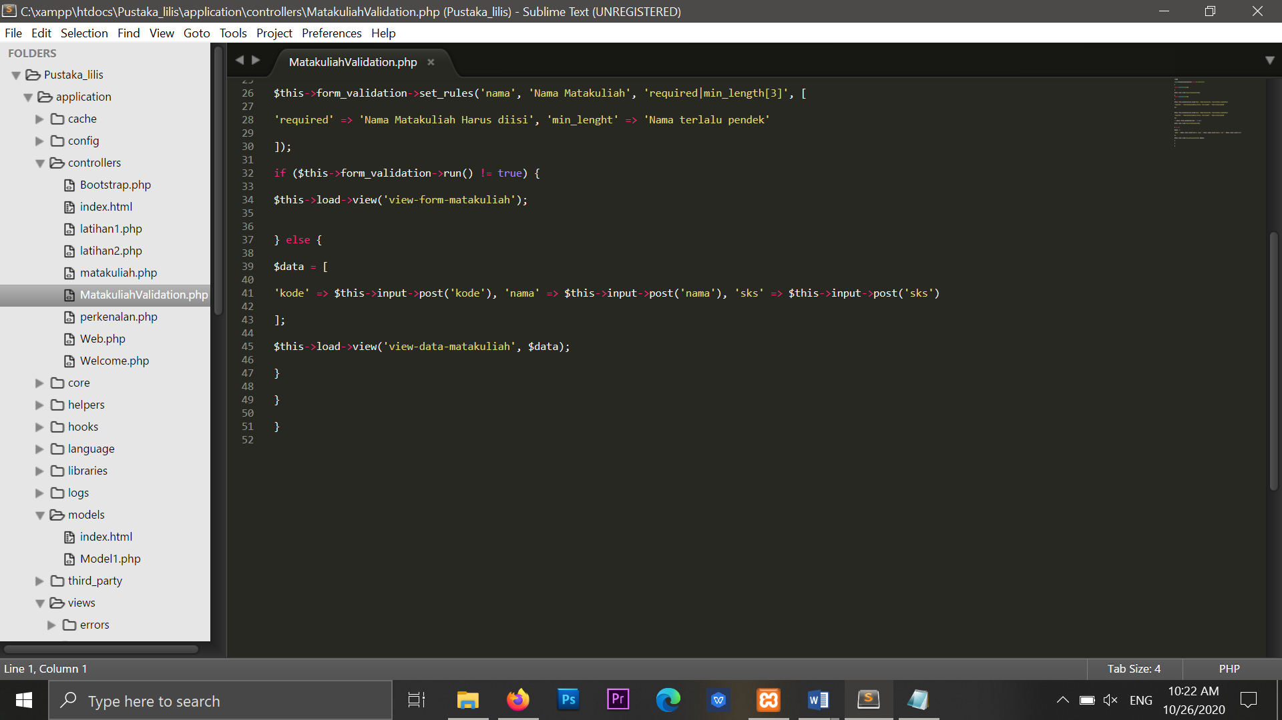

1. URL

<http://localhost/Pustaka_lilis/MatakuliahValidation>

1. Capture Hasil

